ASSIGNMENT-4.1
NAME:AKSHARA JYOTHI.V
ROLL NO: 2303A51793
BATCH NO:12
Analyze the sample example problem and complete the given problem statement 1,2
Advanced Prompt Engineering – Topic Classification of News Headlines
Sample Example Problem:
Problem Statement 0:
A news aggregation platform wants to automatically categorize headlines into Politics, Sports, Technology, and Entertainment without training a machine learning model.
Tasks to be Completed
1. Prepare Sample Data
Collect 10 news headlines, each belonging to one of the four categories.
2. Zero-shot Prompting
Write a prompt asking the LLM to classify a headline into a category without examples.
3. One-shot Prompting
Add one labeled headline example before classifying a new headline.
4. Few-shot Prompting
Use 3–5 labeled headlines in the prompt before requesting classification.
5. Evaluation
Compare outputs from all three prompting methods using the same test headlines and document observation Sample Solution for problem statement 0:
1. Sample News Headlines
No. News Headline Category
H1 Government announces new education policy Politics
H2 Parliament passes new tax reform bill Politics
H3 India wins the T20 cricket series Sports
H4 Football club signs a new international player Sports
H5 Tech company launches a new AI-powered smartphone Technology
H6 Cybersecurity firm reports major data breach Technology
H7 Upcoming movie breaks box office records Entertainment
H8 Popular actor announces next film project Entertainment
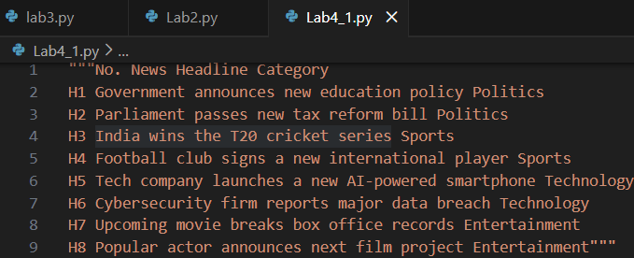
2. Zero-shot Prompting
Prompt Used:
Classify the following news headline into one of these categories:
Politics, Sports, Technology, Entertainment.
Headline: “India wins the T20 cricket series.”
Output:
Sports
Observation:
The model correctly classified the headline without using any example.
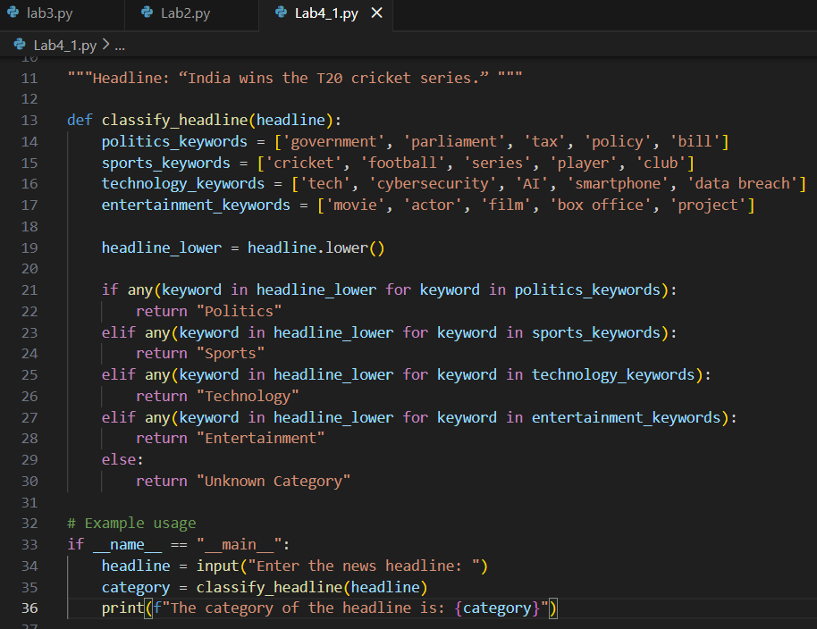
OUTPUT:
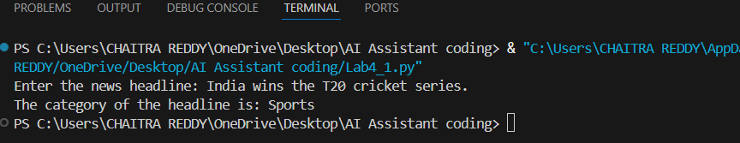
3. One-shot Prompting
Prompt Used:
Example:
Headline: “Government announces new education policy”
Category: Politics
Now classify the following headline into Politics, Sports,
Technology, or Entertainment.
Headline: “Tech company launches a new AI-powered
smartphone.”
Output:
Technology
Observation:
Providing one example improved clarity and consistency in
classification.
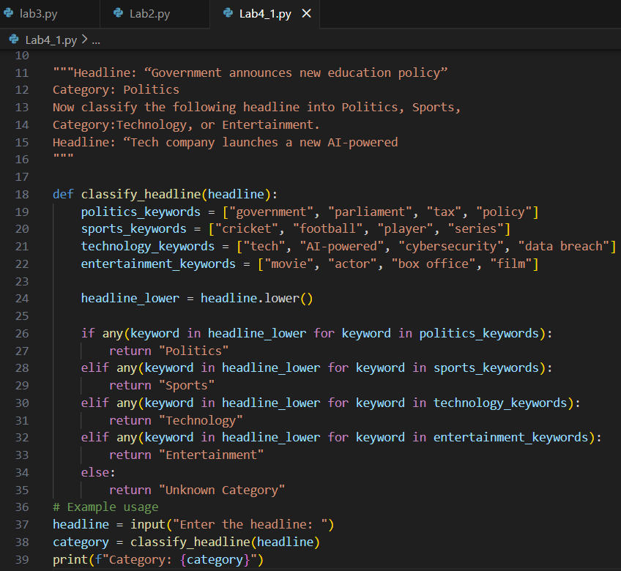
OUTPUT:
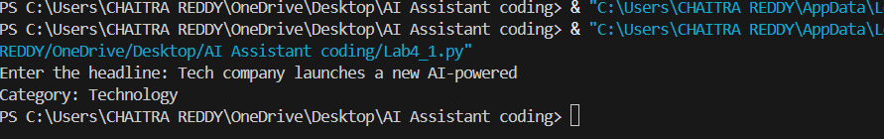

4. Few-shot Prompting
Prompt Used:
Example 1:
Headline: “Parliament passes new tax reform bill”
Category: Politics
Example 2:
Headline: “Football club signs a new international player”
Category: Sports
Example 3:
Headline: “Cybersecurity firm reports major data breach”
Category: Technology
Example 4:
Headline: “Upcoming movie breaks box office records”
Category: Entertainment
Now classify the following headline into Politics, Sports,
Technology, or Entertainment.
Headline: “Popular actor announces next film project.”
Output:
Entertainment
Observation:
Few-shot prompting produced the most accurate and confident
Response
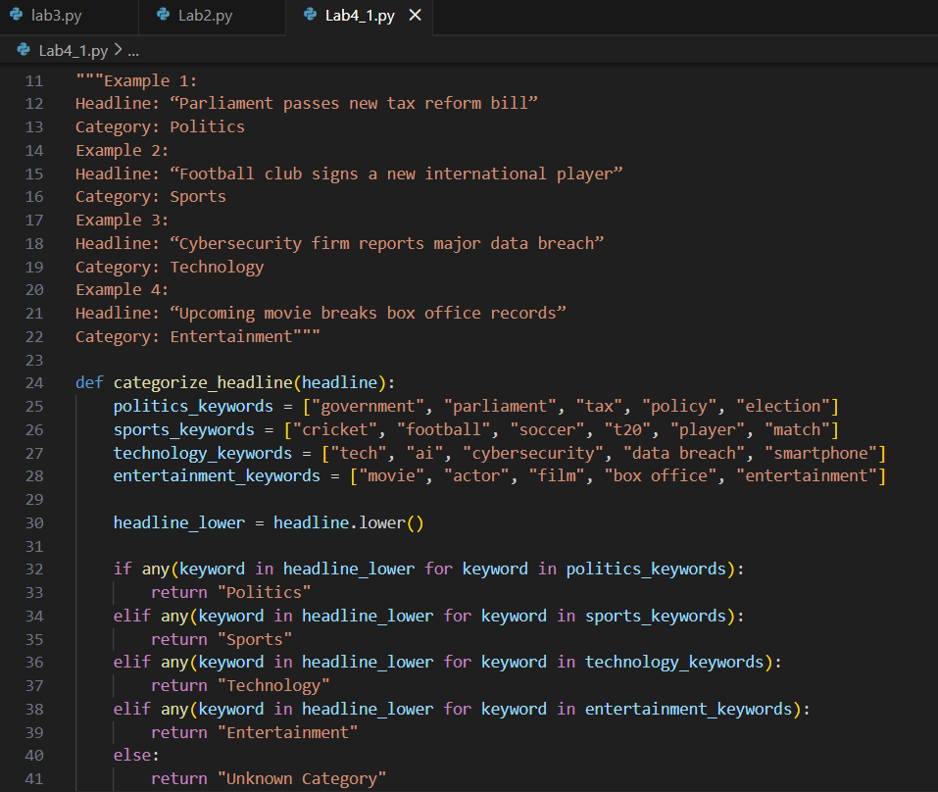
OUTPUT:
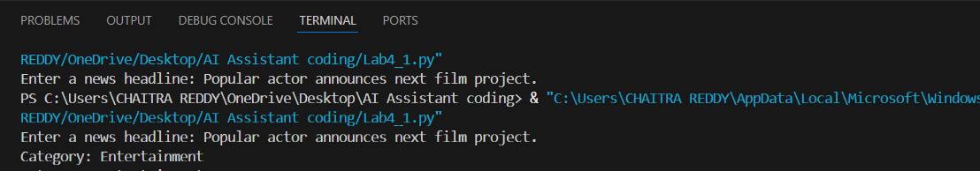
Customer Email Classification
A company receives a large number of customer emails every day and wants to automatically classify them into the following categories:
• Billing
• Technical Support
• Feedback
• Others
Instead of training a new machine learning model, the company decides to use prompt engineering techniques with an existing large language model.
Tasks
1. Prepare five short sample emails, each belonging to one of the above categories.
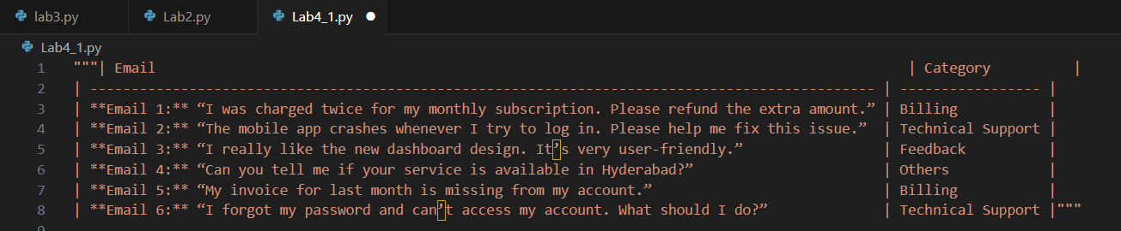
2. Write a zero-shot prompt to classify a given email into one of the categories without providing any examples.
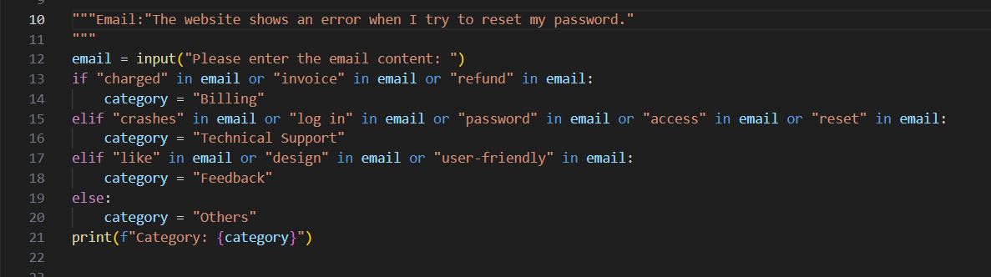
OUTPUT:
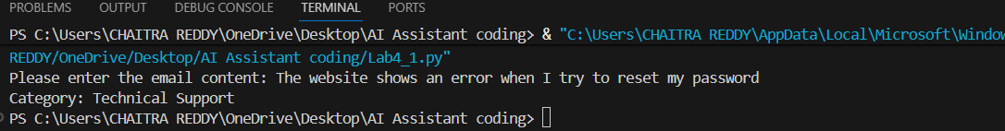
3. Write a one-shot prompt by including one labeled email example and ask the model to classify a new email.
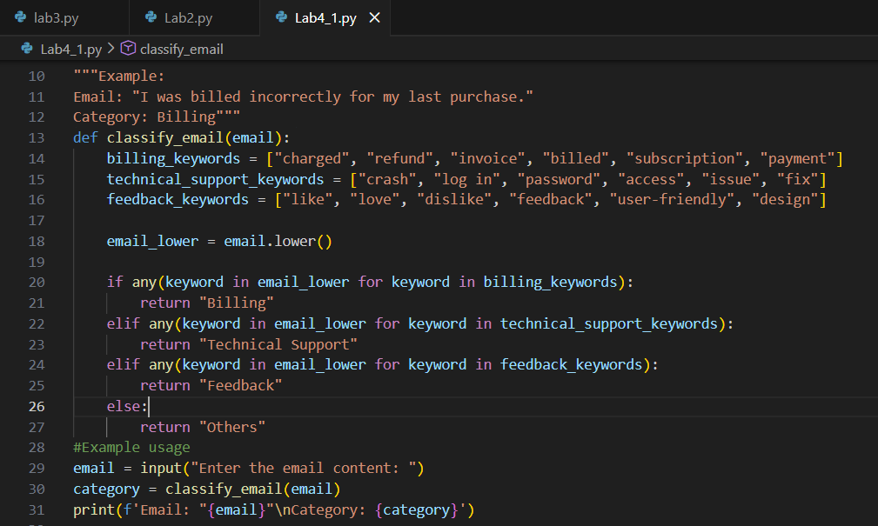
OUTPUT:

4. Write a few-shot prompt by including two or three labeled email examples and ask the model to classify a new email.
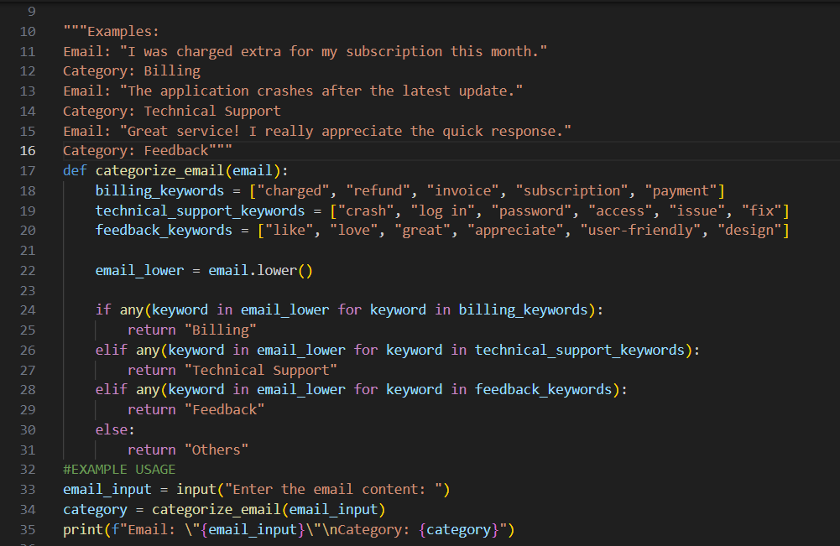
OUTPUT:
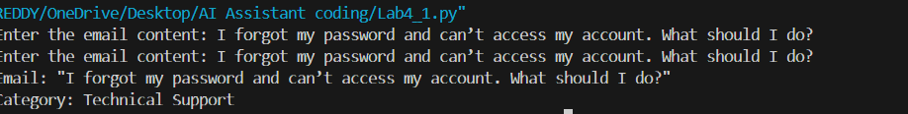

Intent Classification for Chatbot Queries
A company wants to deploy a chatbot to handle customer queries. Each query must be classified into one of the following intents:
Account Issue, Order Status, Product Inquiry, or General Question using prompt engineering techniques.
Tasks to be Completed
1. Prepare Sample Data
Create 6 short chatbot user queries, each mapped to one of the four intents.
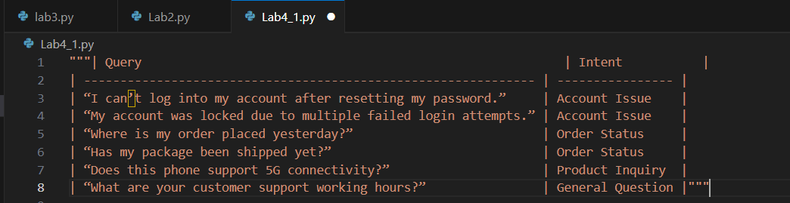
2. Zero-shot Prompting
Design a prompt that asks the LLM to classify a user query into the given intent categories without examples.
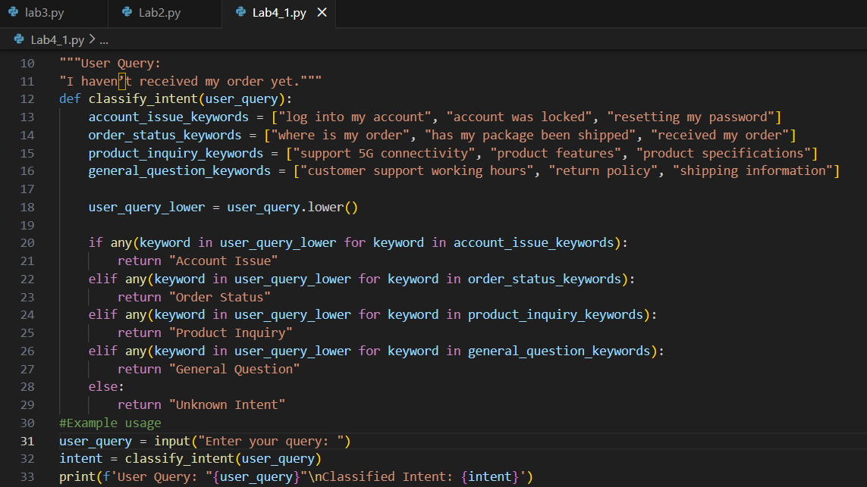
OUTPUT:
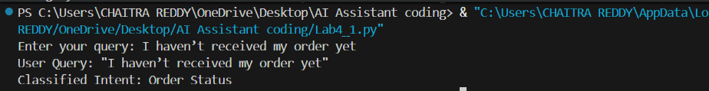
3. One-shot Prompting
Provide one labeled query in the prompt before classifying a new query.
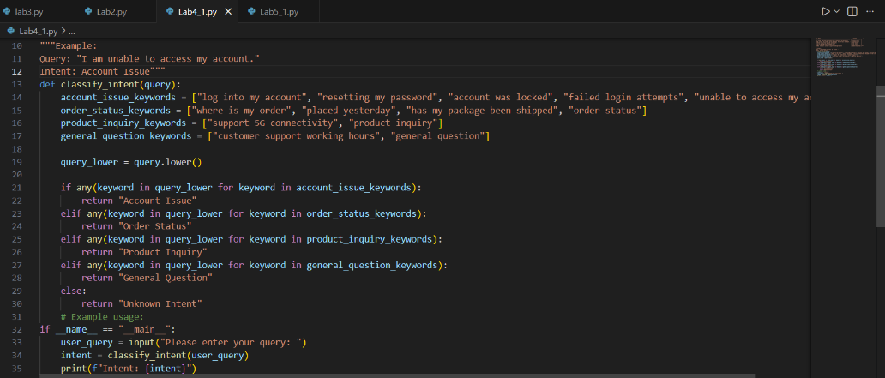
OUTPUT:

4. Few-shot Prompting
Include 3–5 labeled intent examples to guide the LLM before classifying a new query.
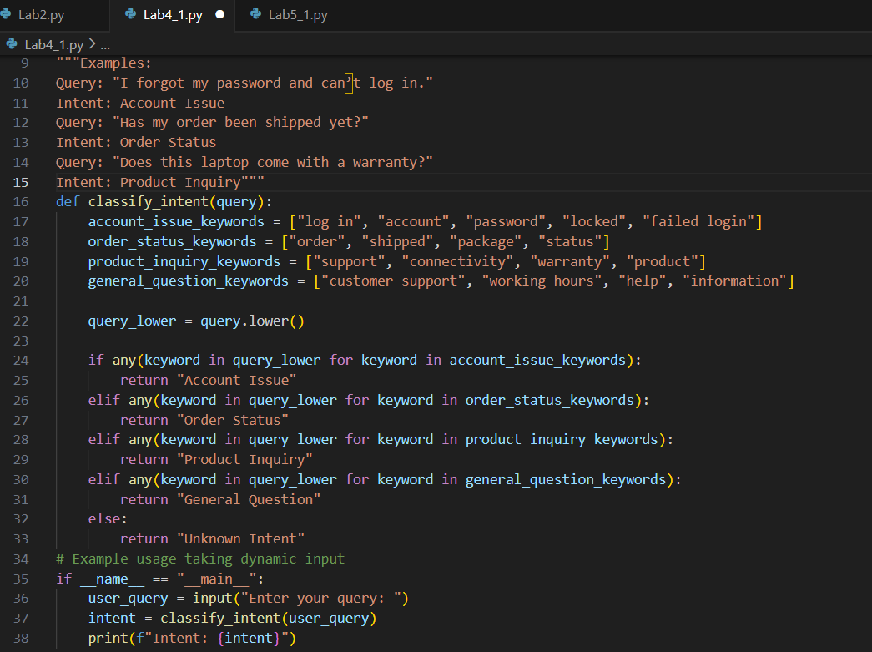
OUTPUT:
Student Feedback Analysis
A university collects student feedback and wants to categorize comments as Positive, Negative, or Neutral.
Questions:
- Write a Zero-shot prompt to classify feedback sentiment.
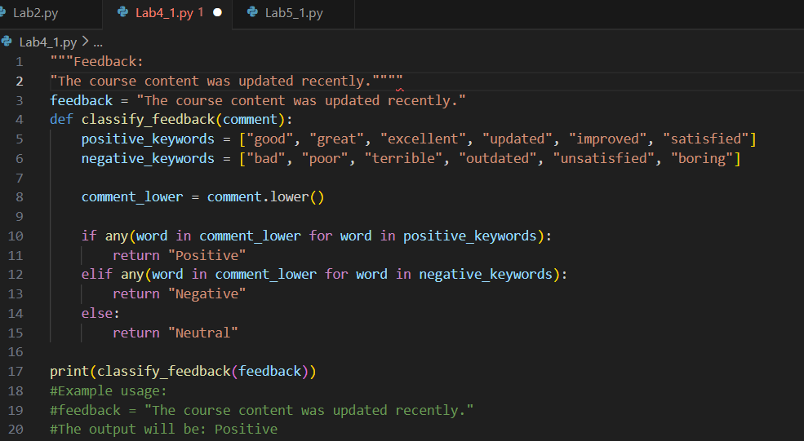
- Provide a One-shot prompt with one feedback example.
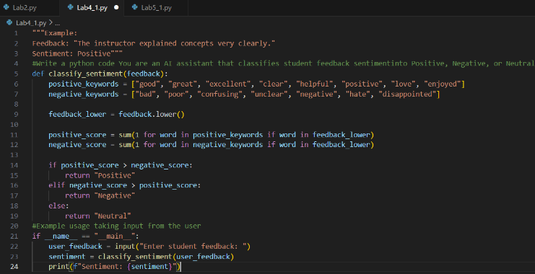
OUTPUT:
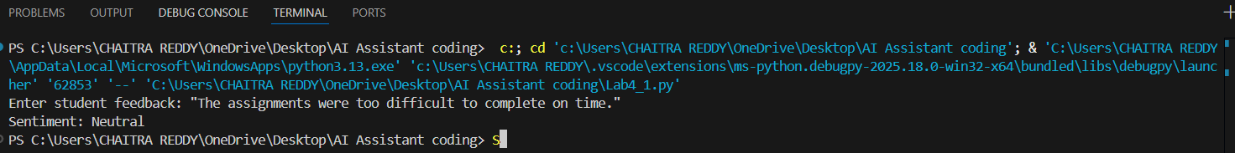
c) Create a Few-shot prompt using multiple labeled feedback samples.
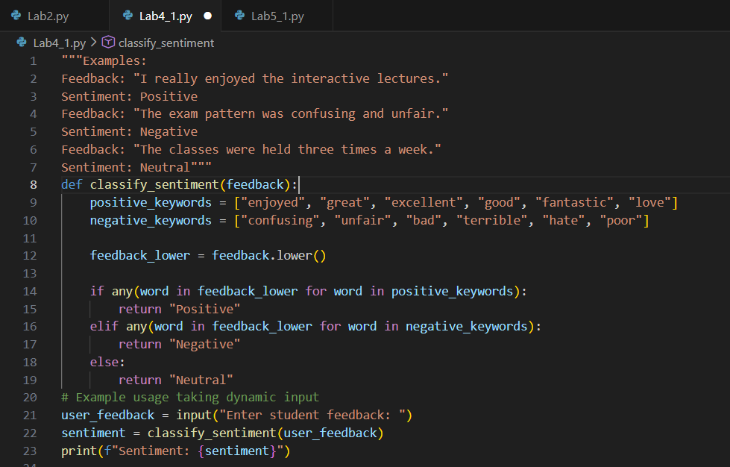
OUTPUT:
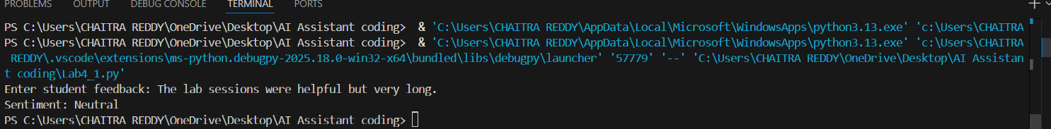
- Explain how examples improve sentiment classification accuracy.
• Examples help the model understand what kind of language corresponds to each sentiment.
• They reduce confusion in ambiguous or mixed feedback.
• Few-shot prompting improves consistency and accuracy by providing clear sentiment patterns.
Course Recommendation System
An online learning platform wants to recommend courses by classifying learner queries into Beginner, Intermediate, or Advanced levels.
Questions:
- Write a Zero-shot prompt to classify learner queries.
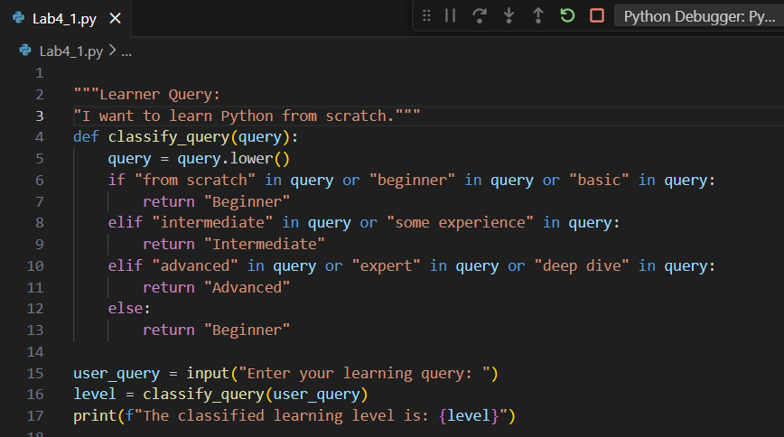
OUTPUT:
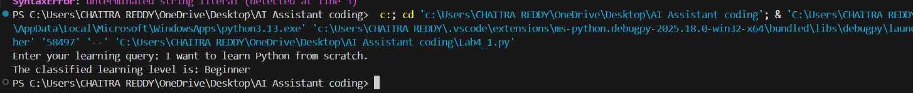

- Create a One-shot prompt with one example query.
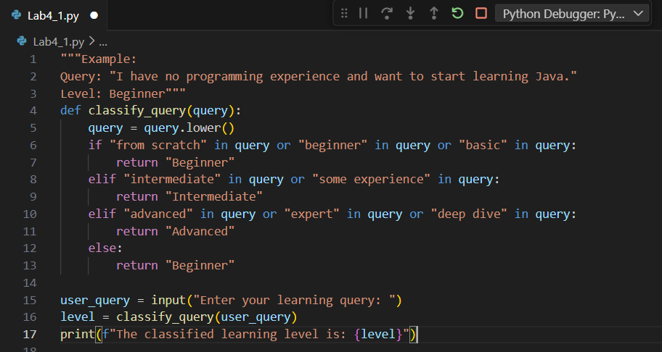
OUTPUT:

- Develop a Few-shot prompt with multiple labeled queries.
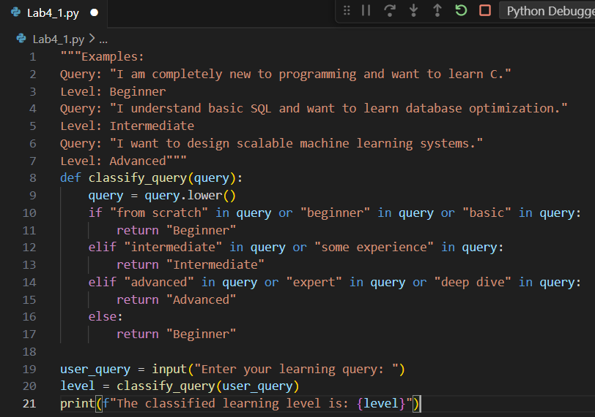
OUTPUT:

- Discuss how Few-shot prompting improves recommendation quality.
• Multiple examples help the model clearly differentiate skill levels.
• Reduces misclassification for ambiguous learner queries.
• Improves accuracy and consistency in recommendations.
• Provides better context understanding, leading to more relevant course suggestions.

Social Media Post Moderation
A social media platform wants to classify posts into Acceptable, Offensive, or Spam.
Questions:
- Write a Zero-shot prompt for post moderation.
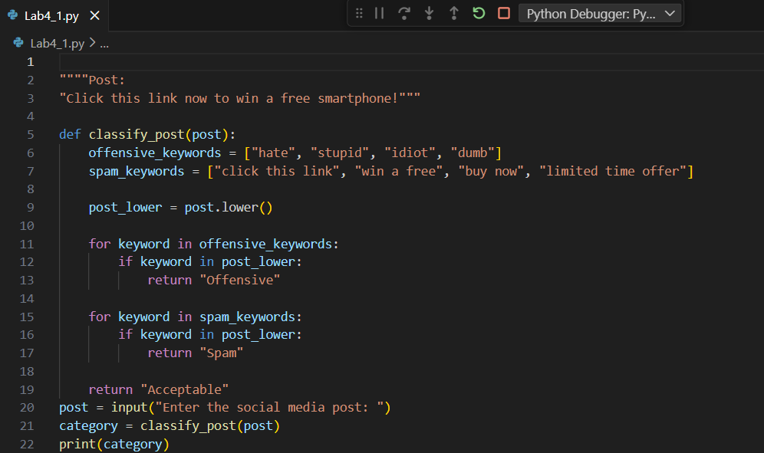
OUTPUT:
- Convert it into a One-shot prompt.
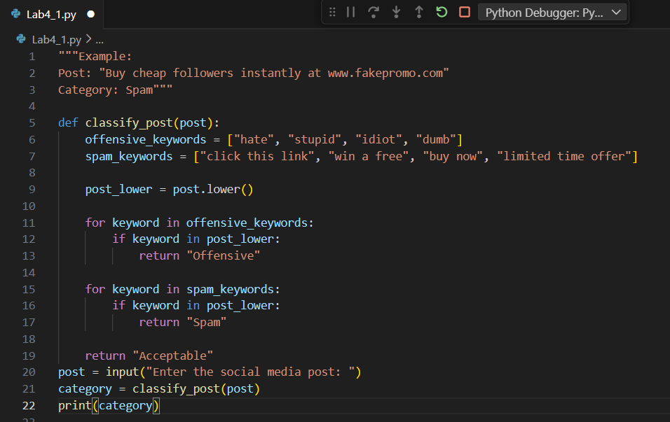
OUTPUT:
- Design a Few-shot prompt using multiple examples.
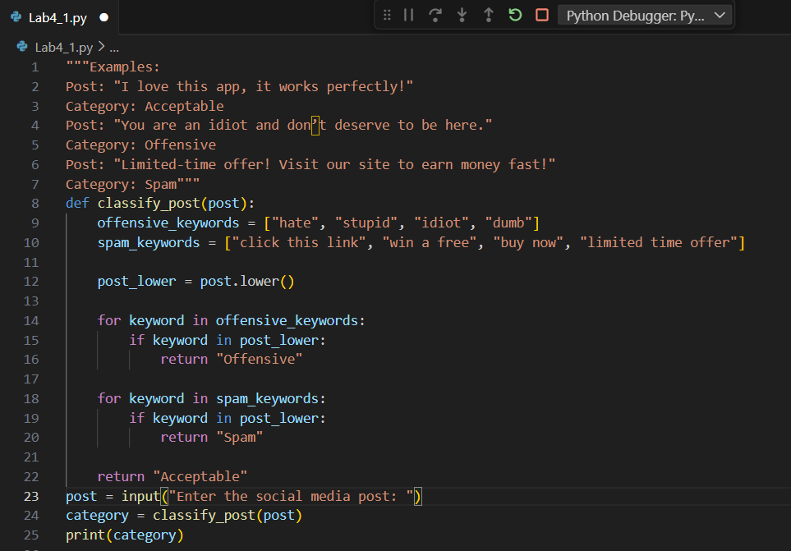
OUTPUT:
- Explain the challenges of Zero-shot prompting in content moderation.
• Zero-shot prompts lack examples, making ambiguous posts harder to classify.
• Subtle sarcasm or indirect offensive language may be misinterpreted.
• The model may confuse criticism with offensive content.
• Accuracy is lower compared to one-shot or few-shot prompting due to limited context.

